

**TRIBHUVAN UNIVERSITY**

**Faculty of Humanities and Social Science**

Job Portal

A PROJECT REPORT

**Submitted To**

Department of Computer Application

Shahid Smarak College

***In partial fulfillment of the requirements for Bachelor in Computer Application(BCA) Final Year***

**Submitted By**

Atit Dangaura Tharu [26202033]

December, 2024

**Under the Supervision of**

Hari Lal Chalise



**TRIBHUVAN UNIVERSITY**

**Faculty of Humanities and Social Sciences**

**Shahid Smarak College**

# SUPERVISOR’S RECOMMENDATION

I hereby recommend that this project prepared under my supervision by **Atit Dangaura Tharu** entitled “Job Portal with recommendation and automation system” in partial fulfillment of the requirements for the degree of Bachelor of Computer Application is recommended for the final evaluation.

………………………..

Mr. Hari Lal Chalise

SUPERVISOR

Shahid Smarak College

Kirtipur, kathmandu



**TRIBHUVAN UNIVERSITY**

**Faculty of Humanities and Social Sciences**

**Shahid Smarak College**

# LETTER OF APPROVAL

This is to certify that this project prepared by ATIT DANGAURA THARU entitled “Job Portal” in partial fulfillment of the requirements for the degree of Bachelor In Computer Application has been evaluated. In our opinion it is satisfactory in scope and quality as a project for the required degree.

|  |  |
| --- | --- |
| ……………………  Mr. Hari Lal Chalise  **SUPERVISOR**  Shahid Smarak College  Kirtipur, Kathmandu | ……………………..  Mr. Sanjay Gyawali  **COORDINATOR**  Shahid Smarak College  Kirtipur, Kathmandu |
| …………………………  **Internal Examiner** | ……………………………  **External Examiner** |

# ACKNOWLEDGEMENT

I would like to express our special thanks of gratitude to my Supervisor **Mr. Hari Lal Chalise** as well as my coordinator  **Mr. Sanjay Gyawali** who gave us a golden opportunity to do this wonderful project on the topic **Job Portal with Content-Based Filter Recommendation and Automation system**, which also helped us in doing a lot of research and we came to know about so many new things we really thankful to them. In addition, we would also like to thank our parents and friends and our mentor who helped us a lot in finalizing this project within the limited time frame.

Yours Sincerely

ATIT DANGAURA THARU

[ 26202033 ]

# ABSTRACT

Job portal is an online platform that creates the link between employers and job seekers, acting as a medium to enhance the recruitment process. It has revolutionized traditional ways of hiring by offering a more efficient, accessible, and cost-effective solution for both parties involved. This project attempts to investigate the evolution of job portal, key features, and prospects of job portals, highlighting their importance in addressing employment challenges.

New technologies of today have been used, such as content-based filtering recommendation systems and automation systems for sending mail to the matched niches of job seekers. I was used to today’s most popular programming languages: React, Redux, Node.js, Express.js, and MongoDB. These tools are being used in contemporary job portals to make job recommendations more personalized and review resumes. Further features such as skill, location, title-based filtering, and mobile accessibility have increased their efficiency.

This research has concluded that job portals are going to continue changing with new technologies and a user-centered approach to meet the dynamic challenges in the labor market. This will have the potential to democratize access to employment opportunities a fostering economic growth makes them indispensable in today's job market.

**Keyword**: *recruitment, employers, job seekers, recommendation, automation system, resumes*

# TABLE OF CONTENTS

SUPERVISOR’S RECOMMENDATION i

LETTER OF APPROVAL ii

ACKNOWLEDGEMENT iii

ABSTRACT iv

TABLE OF CONTENTS v

LIST OF FIGURES vii

LIST OF TABLES viii

List OF APPENDICES ix

LIST OF ABBREVIATIONS x

CHAPTER 1: INTRODUCTION 1

1.1. Introduction 1

1.2. Problem Statement 1

1.3. Objectives 1

1.4. Scope and Limitation 1

1.4.1. Scope: 1

1.4.2. Limitation: 2

1.5 Development Methodology 2

1.6 Report Organization 3

CHAPTER 2: BACKGROUND STUDY AND LITERATURE REVIEW 4

2.1. Background study 4

2.2. Literature Review 5

CHAPTER 3: SYSTEM ANALYSIS AND DESIGN 8

3.1. System Analysis 8

3.1.1. Requirement Analysis 8

3.1.2. Feasibility Analysis 9

3.1.3. Object Modelling using Class and Object Diagrams 12

3.1.4. Dynamic Modelling using State and Sequence Diagrams 14

3.1.5. Process Modelling using Activity Diagrams 16

3.2. System Design 17

3.2.1. Component Diagram 17

3.2.2. Deployment Diagrams 18

3.3. Algorithm Details 18

CHAPTER 4: IMPLEMENTATION AND TESTING 21

4.1. Implementation 21

4.1.2. Implementation Details of Modules 22

4.2. Testing 23

4.2.1 Test Cases for Unit Testing 23

4.2.2 Test Case for System Testing 26

CHAPTER 5: CONCLUSION AND FUTURE RECOMMENDATIONS 28

5.1. Conclusion 28

5.2. Future Recommendations 28

REFERENCES 29

APPENDICES 30

# LIST OF FIGURES

Figure 1.1: Water Fall Model for Job Portal 2

Figure 3.1: Gantt Chart for Job Portal 11

Figure 3.2: Class Diagram for Job Portal 12

Figure 3.3: Object Diagram for Job Portal 13

Figure 3.4: Sequence Diagram for Job Portal 14

Figure 3.5: State Diagram for Job Portal 15

Figure 3.6: Activity Diagram for Job Portal 16

Figure 3.7: Component Diagram for Job Portal 17

Figure 3.8: Deployment Diagram for Job Portal 18

# LIST OF TABLES

**Table 4.**1**: Unit Testing for Job Portal** 23

Table 4.2: System Testing for Job Portal 26

# List OF APPENDICES

Appendix 1: Home Page for Job Portal 31

Appendix 2: Job Searching page for Job Portal 31

Appendix 3: Job Filter by Niches for Job Portal 32

Appendix 4: Single Job Description & Recommendationfor Job Portal 32

Appendix 5: Application Form for Job Portal 33

Appendix 6: login Pagefor Job Portal 33

Appendix 7: Admin Profilefor Job Portal 34

Appendix 8: Post New Jobs Formfor Job Portal 34

Appendix 9: User applicationsfor Job Portal 35

Appendix 10: Posted Jobfor Job Portal 35

# LIST OF ABBREVIATIONS

AI Artificial Intelligence

ASYNC Asynchronous

CV Curriculum Vita

DB Database

DOCX Office Open Extensible Markup Language

ID Identity

JS JavaScript

KNN K-Nearest Neighbors

**NLP Natural Language Processing**

PDF Portable Document Format

RFC Random Forest Classification

SQL Structure Query Language

SVM Support Vector Machine

UML Unified Modeling Language

# CHAPTER 1: INTRODUCTION

## 1.1. Introduction

Job portal is an online platform designed to connect job seekers with employers. It serves as a bridge between individuals seeking employment and organizations looking to hire talent. Job portal streamlines the recruitment process by providing tools for posting, searching, and applying for jobs. This system is made to both job seekers and admin to engage very quickly by providing free platform in the world.

Job portals have emerged as essential platforms in the modern job market, facilitating connections between job seekers and employers. These online applications streamline the recruitment process by allowing users to create profiles, search for job openings, and apply directly to companies. They provide diverse needs, providing tailored job listings based on qualifications and preferences, thus enhancing the efficiency of job searches and recruitment efforts.

## 1.2. Problem Statement

There have been many job portal but in today's competitive job market, job seekers often face challenges in finding opportunities that align with their skills, preferences, and aspirations. Similarly, employers struggle to attract the right candidates for their job openings. Despite the availability of various job portals, many platforms fail to deliver personalized job recommendations, leading to inefficiencies and missed opportunities for both job seekers and employers.

## 1.3. Objectives

The main objectives of this developed project are as follows:

* To provide a centralized platform of jobs
* To simplify the process of posting job and manage applications
* To offer job Recommendations tailored to users given details like location, title, salary

## 1.4. Scope and Limitation

### 1.4.1. Scope:

* Nepal’s significant youth population is actively seeking jobs locally and internationally, so it can be used in a good way to find the right job with their skill, preference, location etc.
* Growing internet access in Nepal provides a platform for digital job search services to expand.
* A portal can offer skill-building resources, career counseling, and workshops, addressing gaps in employability.
* Allow employers to showcase their brand to attract top talent.

### 1.4.2. Limitation:

In this system has not been added payment, employer cannot register that all job posting work is done by admin. So, there are some limitations on this job portal.

## 1.5 Development Methodology

The waterfall model can make project management easier for this project. It provides clear phases for software development, with each phase building upon the previous one. This structure might make it easier to plan and manage the project, as you have a clear road map to follow.

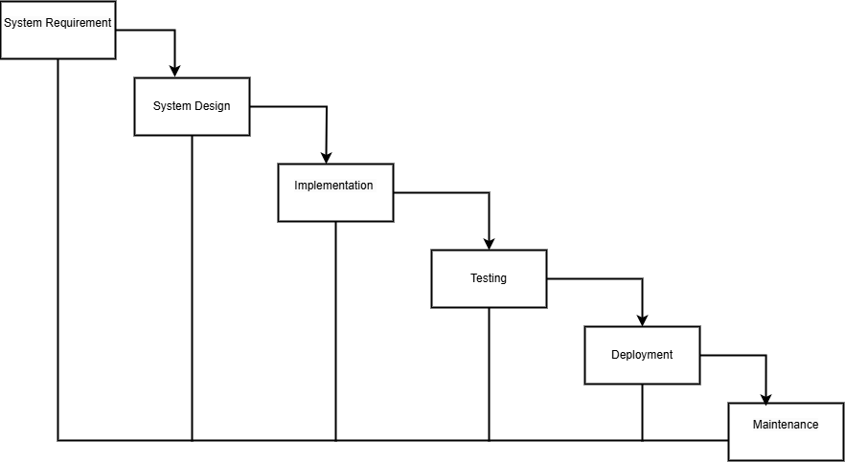

**Figure** 1**.1: Water Fall Model for Job Portal**

## 1.6 Report Organization

Chapter 1: Introduction: This chapter serves as an introduction to the project, presenting the problem statement, project objectives, as well as the project's scope and limitations. It aims to provide readers with a comprehensive overview of the project.

Chapter 2: Background study and Literature review: This chapter encloses background study and literature review, focusing on a similar project and the relevant concepts associated with the current project. Its aim is to provide an understanding of the project by examining previous research.

Chapter 3: System Analysis and Design: This chapter encompasses the workings of the project including feasibility analysis, functional and non-functional analysis along with the schema and architectural design and the data and process modeling diagrams.

Chapter 4: Implementation and Testing: This chapter encompasses the testing and implementation phase of the project, which involves the design of test cases to ensure the system, and its components function as intended during the development process. It also includes an overview of the tools utilized in the construction of the project.

Chapter 5: Conclusion and Future Recommendations: It contains the conclusion of the entire project. In addition to these things the future recommendations for the project are also listed at the end of chapter 5.

# CHAPTER 2: BACKGROUND STUDY AND LITERATURE REVIEW

## 2.1. Background study

This study took a few days to understand that the platform for making new features added site to work with the two types of stakeholders. Online job portals have become indispensable tools for modern recruitment, revolutionizing the way job seekers and employers connect. Platforms such as LinkedIn, kumari job, and Jobs Nepal dominate the global market, offering features that cater to both job seekers and employers. These platforms allow job seekers to browse through vast arrays of opportunities while enabling employers to post job openings and search for suitable candidates. Their user-friendly interfaces, advanced search capabilities, and seamless application processes have made them the go-to solutions for millions of users worldwide. Additionally, region-specific portals like Rozee in Pakistan and merojob in Nepal address local employment needs by tailoring services to regional languages, industries, and market dynamics.

A detailed analysis of these portals reveals a common emphasis on personalized user experiences driven by technology. Job portals leverage AI and machine learning to recommend jobs based on user profiles and browsing behavior. Features like skill assessments, resume-building tools, and company reviews further enhance their value proposition. Many portals have also introduced freelancing and gig opportunities, reflecting the growing demand for flexible work arrangements. Additionally, mobile-first strategies have enabled platforms to reach a wider audience, particularly in regions where smartphones are the primary mode of internet access.

Despite their advantages, online job portals face challenges such as data privacy concerns, fraudulent postings, and accessibility gaps for users in rural or underserved areas. For example, platforms often struggle to verify the authenticity of job listings, exposing users to scams. Moreover, users with limited digital literacy or internet access face barriers in utilizing these services effectively. However, innovations like blockchain for credential verification, partnerships with government agencies, and mobile-friendly designs are addressing these issues. As these platforms continue to evolve, they are poised to play an even greater role in bridging the gap between employers and job seekers, fostering a more efficient and inclusive job market globally.

## 2.2. Literature Review

The paper discusses enhancing job portals through personalized recommendation systems using machine learning techniques. It highlights the effectiveness of content-based filtering and deep learning methods, particularly the random forest approach, in improving user engagement and optimizing job recommendations. The employment market in today’s modern society is growing increasingly active, which makes choosing a clear opportunity for yourself a difficult endeavor, particularly for newcomers who are unfamiliar with the numerous possible professions. As a result, the need for employment recommendation systems has been steadily increasing. Many systems employ suggestions to provide consumers with personalized solutions. By examining job recommendation articles, we are taking into account various machine learning algorithms as well as models provided in this study. The information in the student’s résumé is compared to the specifications of the job opportunities. Users’ abilities, knowledge, past previous employment, demographic data, as well as other necessary details are extracted from recommendation apps. The applicant is presented with fresh positions that are unrelated to the one being sought based on the extraction of information. We discovered that by using content-based filtering to unsupervised based on deep learning classification methods such as SVM, KNN, and randomized forest, the random forest approach delivers the highest outcomes for our applications. Python is used to construct the recommendation engine [1].

The paper discusses developing a job recommendation system using NLP and filtering techniques to enhance user engagement. It focuses on matching job seekers with suitable opportunities, optimizing the job search process through personalized recommendations based on skills and resumes. The research aims to create a job recommendation system using data from job portals and social media, employing web mining and NLP to analyze this data effectively [2].

 This paper focuses on the job portal websites. The research objective of this paper is that the recommender framework takes the abilities from the website and makes suggestion to the candidates with the jobs whose descriptions are coordinating with their profiles the most. This paper additionally presents a short presentation on recommender framework and talks about different categories of this framework. From the start, information is cleaned by expelling the filthy information as extra space and duplicates. Then the job recommendations are made to the target applicants on the basis of their preferences. It utilizes different machine learning procedures which results show that  RFC gives the most noteworthy expectation accuracy when contrasted with different procedures. Finally, the optimization technique is utilized to get the most exact outcome. The advantage of recommender framework in career orientation is expressed. Geo-area based recommendation framework is utilized to find the organization's position which can assist the ideal applicants with reaching their destination. This examination shows that the utilization of job  recommendation system can assist with improving the recommendation of appropriate employment for work searchers [3].

The study indicates that online job portals influence traditional recruitment by enhancing accessibility and efficiency. However, concerns about usability and trustworthiness affect job seekers' experiences, prompting employers to improve job portal functionalities for better recruitment outcomes and candidate satisfaction [4].

The paper discusses how these systems are essential in managing information overload by customizing news content to fit individual user preferences. This personalization is achieved through advanced algorithms that analyze user data to deliver relevant news articles. A significant focus is placed on the algorithms that power these recommendation systems. The paper explains that these algorithms use sophisticated techniques to analyze user data and adapt to their preferences in real-time, which is crucial for enhancing user engagement. The paper reviews two primary techniques used in recommendation systems: collaborative filtering, which relies on user community preferences, and content-based filtering, which focuses on the attributes of the news articles themselves. Each method has its strengths and challenges, such as the cold start problem in collaborative filtering [5].

The paper discusses the rapid growth of artificial intelligence and machine learning technologies. The recommendation system aims to help users find items that match their preferences. To improve performance, many recommendation system techniques have been proposed. This paper presents a survey of some common recommendation techniques and related issues with advantages and disadvantages. At the same time, the different types of job recommendation systems are described in detail and compared with each other. The goal is to provide a comprehensive overview of the current state of job recommendation systems and to analyze the characteristics of each system. The results of the case studies can contribute to a better understanding of the strengths and weaknesses, as well as techniques used in different job recommendation systems. Through this review, insights are provided to guide the development of more effective recommendation systems. For future research, a system is proposed to generate career move recommendations with upskilling and reskilling suggestions [6].

The paper explains the development of internet technology online job hunting has been boosted as it helps to save time and efforts, [theory providing ease of search]. It's hard for job seekers to rely solely on keyword acquisition to find a job that befits their needs. To overcome this problem, the system will be made using article-based collaborative filtering and content-based filtering job recommended algorithm. The proposed system will be notified where the information about various jobs could be scrapped from vivid websites to form a huge database comprising the majority of information regarding real time job opportunities. The users' information would be fetched from the CV submitted with our data from the dataset and recommendations would be provided on the same. This would prove to be of greater help as one doesn't have to hunt across varied websites. Job recommender systems' goal is to offer suggestions based on data about the users' preferences that has been recorded. The major goal is to provide skill recommendations to users so they can learn them, discover appropriate work, and streamline the application process for both novice and seasoned job seekers. The difficulties lie in identifying the best individuals based on their skill sets [7].

The aim of the research paper is to grow online search portals as well as provide proper login in search portals. The importance of placement increases day by day because people in many sectors in their daily life or work depend on placements cells. A job portal helps job seekers and recruiters find the right organization for the employees. The job portals show the list of companies to the job explorers and the recruiters. There are three modules. Admin, Recruiter and Jobseeker or applicant. The admin has control over the complete portal. Recruiter after registration can post jobs, view applicant profile. Jobseeker can register for free in our portal and can search and apply for jobs that he wants [8].

# CHAPTER 3: SYSTEM ANALYSIS AND DESIGN

## 3.1. System Analysis

### 3.1.1. Requirement Analysis

Identifying requirements for a job portal involves gathering and documenting the functional and non-functional needs of the system. These requirements are essential for ensuring that the job portal meets the expectations of all stakeholders, including job seekers, employers, and administrators. Here’s a breakdown of the key requirements:

Requirement Analysis

#### 3.1.1.1. Functional Requirements

These define what the system should do.

**a. User Registration and Authentication**

* Users (job seekers) should be able to register and log in to the portal.
* Support authentication methods (e.g., email/password).

**b. Profile Management**

* Job Seekers: Ability to create, update, and manage profiles including resumes, cover letters, and personal details.
* Admin: Ability to create company profiles, including company information, requirements and contact details.

**c. Job Posting and Management**

* Admin should be able to post job vacancies with details like job title, Introduction, job type, qualification, company Name, responsibility, location, offer and salary.
* Ability to delete job postings.

**d. Job Search and Filtering**

* Job seekers should be able to search for jobs using various filters like keywords and location.

**e. Application Process**

* Job seekers should be able to apply for jobs directly through the portal.
* Admin should be able to receive and manage applications, view candidate profiles, and download resumes.

**f. Dashboard**

* Job Seekers: Dashboard showing profile details, update password, job applications, applied jobs, and saved jobs.
* Admin: Dashboard to manage job postings, view the job grid, applications.

#### 3.1.1.2. Non-Functional Requirements

These define the system’s behavior and attributes.

**a. Scalability**

* The system should be scalable, able to handle large numbers of users, job postings, and applications without a loss in performance.

**b. Security**

* Ensure secure data transmission and storage, especially for sensitive user information.

**c. Performance**

* Fast load times and responsive interface, with minimal downtime.
* Efficient search algorithms to handle large volumes of job postings and user queries.

**d. Usability**

* user-friendly interface, with clear navigation and easy-to-use features.
* Accessibility features to support users with disabilities.

**e. Compatibility**

* Cross-browser compatibility and optimization for different screen sizes, especially mobile devices.

**f. Reliability**

* High availability with backup and recovery options in case of system failure.
* Regular updates and maintenance to ensure the system remains reliable.

**g. Maintainability**

* The system should be easy to maintain, with clear documentation and modular architecture to support updates and feature enhancements.

### 3.1.2. Feasibility Analysis

This chapter describes all the feasibilities that comes as question to both the developers and other users during the development of software. The chapter contains technical feasibility, operational feasibility and economic feasibility.

**a. Technical Analysis**

Technical feasibility study is concerned with specifying equipment and software that will successfully satisfy the user requirement; the technical needs of the system may vary considerably. The facility to produce outputs each time. This project is a web-based application which is based on client-server-based application. In this application every page as output is rendered from server to client so it is necessary that the page should be rendered in time. For this I have avoided more and more code in the page- load event.

**b. Operational Analysis**

Operation feasibility is used to check whether the project is operationally feasible or not. This project is mainly different from the other system because of its web-support feature. So, the measure for operational feasibility is something different from other systems. Generally, the operational feasibility is related to organizational aspects. The change determination is as such that early product were either a man or group of men or the jobs based manual but now a day with the advent of Internet technology.

**c. Economic Analysis**

Economic feasibility is the measure to determine the cost and benefit of the proposed system. This project is economically feasible which is under the estimated cost for its development. These benefits and costs may be tangible or intangible. Job Portal is a cost-effective project in which there is less possibility of intangible cost so there is no difficulty to determine the cost of the project.

**d. Schedule Analysis**

The project schedule will outline the tasks, milestones, and timelines for each development phase, including analysis, design, implementation, testing, and deployment. It will also allocate resources and assign responsibilities to ensure timely completion.**Figure** 2**: Gantt Chart for Job Portal**

### 3.1.3. Object Modelling using Class and Object Diagrams

A class diagram is a visual tool that represents the structure of a system by showing its classes, attributes, methods, and the relationships between them. It helps to show the object types of database models in job portal.

Figure 3.1: Class Diagram for Job Portal

An object diagram is a tool that visually represents how objects and interfaces in a system interact at a specific point in time. It's a type of class diagram that shows the instances of classes in a system, along with their relationships: here is main controller is appController that control the all associated component by linking their function name and actually made database model is a userModel, jobModel, and applicationModel is being routed by their router function then these all method controlled by controller.

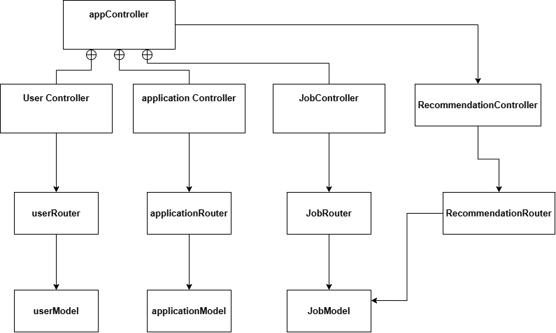

Figure 4.2: Object Diagram for Job Portal

### 3.1.4. Dynamic Modelling using State and Sequence Diagrams

A sequence diagram is a visual representation of how objects or components of a system interact with each other in a specific order. It is a type of interaction diagram that is commonly used in software engineering and systems design. This project used two types of stakeholders like job seeker and employer/admin working with their system component that is finally connected to the database to store / fetch the data and response.

**Figure** 5**: Sequence Diagram for Job Portal**

A state diagram, also known as a state machine or state chart diagram, is a visual representation of the possible states and transitions of a system. Here two types of state diagram has been presented to show the process of the admin to manage dashboard component, other two active step is for job search and selected job recommendations state component’s process to handle the component of job search and recommendations.

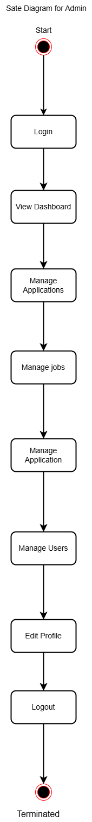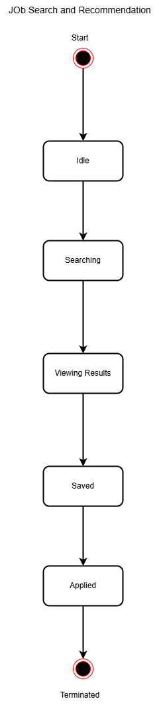

**Figure** 6**: State Diagram for Job Portal**

### 3.1.5. Process Modelling using Activity Diagrams

An activity diagram is a visual representation of a process or system's actions, constraints, requirements, and other factors. The activity diagram used to describe flow of activity through a series of actions. Activity diagram is an important diagram to describe the system. An activity diagram shows the overall flow of control.

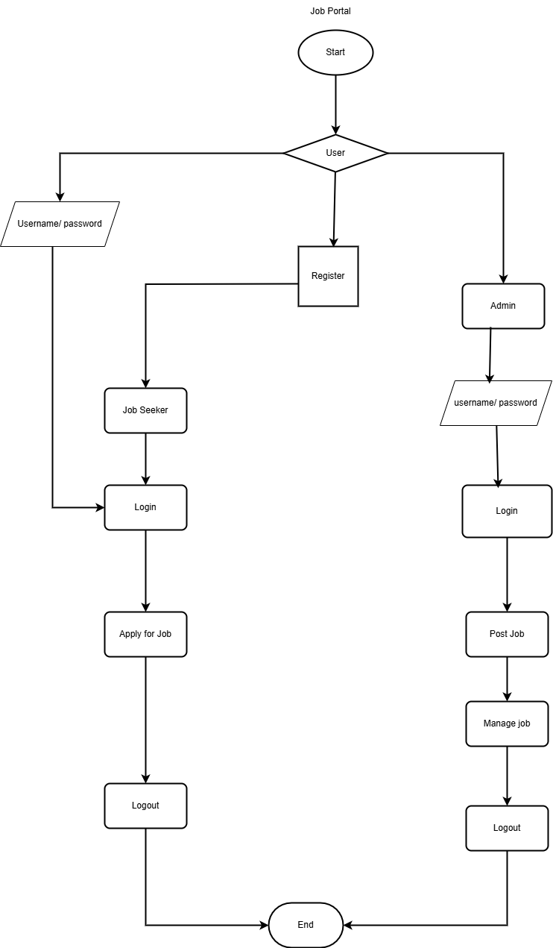

**Figure** 7**: Activity Diagram for Job Portal**

## 3.2. System Design

### 3.2.1. Component Diagram

A component diagram, also known as a UML component diagram, is a visual representation of the structural relationships between the components of a system. In this diagram, my project job portal created component to help it makes more dynamic platform in single page applications.

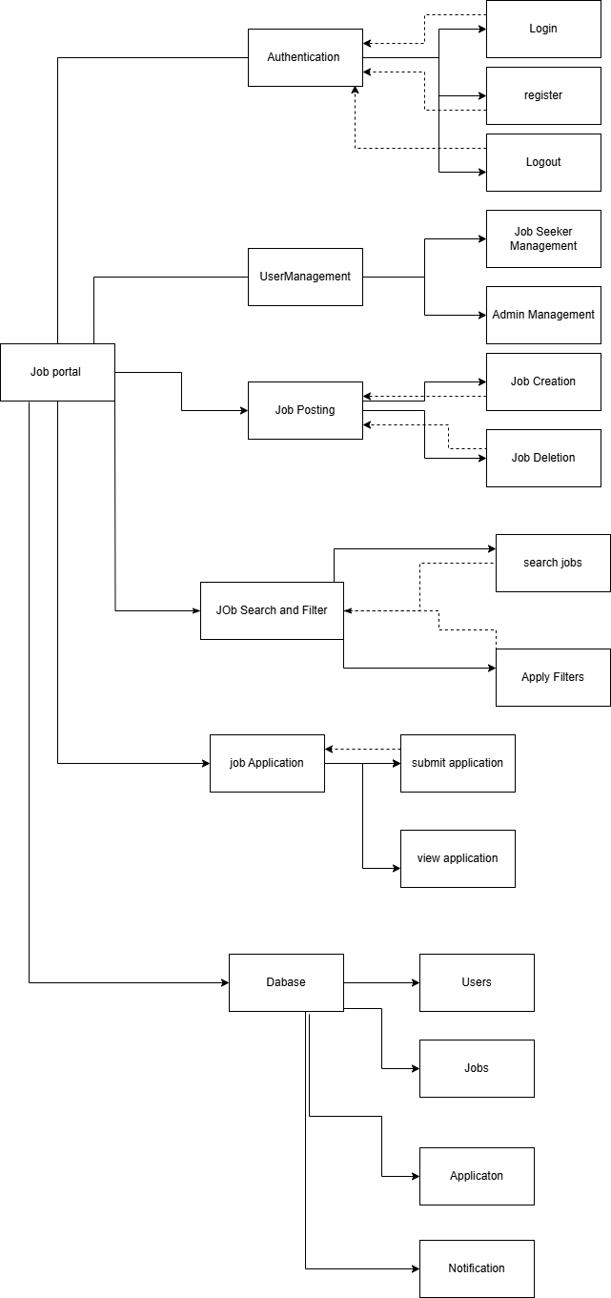

**Figure** 8**: Component Diagram for Job Portal**

### 3.2.2. Deployment Diagrams

A deployment diagram is a type of UML diagram that shows how a system's components are physically deployed. It's used to visualize the hardware and software of a system, and how they interact with each other.

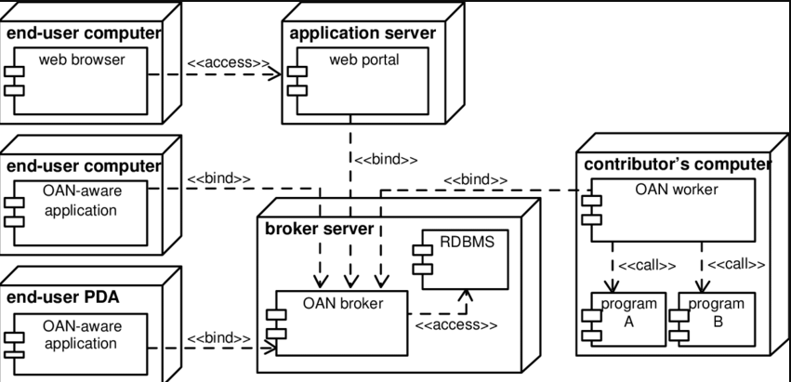

**Figure** 9**: Deployment Diagram for Job Portal**

## 3.3. Algorithm Details

* **Description of Algorithm**

An algorithm is a step-by-step procedure or set of rules used to solve a specific problem or perform a task. It is a systematic and logical sequence of actions designed to transform input into output. Algorithms can be used in various fields such as mathematics, computer science, and daily life to achieve desired results efficiently.

* **Recommendation Algorithm**:

A recommendation algorithm is a combination of datasets and machine learning that provides personalized recommendation based on users’ historical data. The recommended algorithm is used in recommender systems as is a type of data filtering that helps to predict user preference and interests, making it easier to find content or products they might like or be interested in. Rather than showing content you’ve chosen to see such as the pictures and posts of people you follow, these kinds of algorithms show content they think you’ll be interested in based on previews interactions.

// Query to find similar jobs

      const recommendations = await Job.find({

        _id: { $ne: id }, // Exclude the current job

        $or: [

          { title: { $regex: currentJob.title, $options: 'i' } },

          { location: { $regex: currentJob.location, $options: 'i' } },

          { qualifications: { $regex: currentJob.qualifications, $options: 'i' } },

          { jobNiche: { $regex: currentJob.jobNiche, $options: 'i' } },

          { salary: { $regex: currentJob.salary, $options: 'i' } },

        ],

      }).limit(10);

* **Automation Algorithm(newsLetterCrone):**

An **automation recommendation system** in a job portal tailored to job niches uses intelligent algorithms to analyze and match job seekers with the most relevant job opportunities based on specific criteria such as **job preferences**. The system collects data from both job seekers' profiles (such as resumes, job search history, and preferences) and job postings (such as job descriptions, required qualifications, and company details). By leveraging machine learning techniques, the system can automatically recommend jobs that align with the individual’s background and preferences.

This code describes the timing function of mailing system automation by giving to time schedule to trigger the job notification.

cron.schedule("*/1 * * * *", async () => {

    console.log("Running news Letter Cron Automation");

    const jobs = await Job.find({ newsLettersSent: false });

For instance, if a job seeker has a background in software development with an interest in remote work, the recommendation engine can prioritize listings that match these preferences. Similarly, if a user is actively seeking positions in a particular industry, such as healthcare or marketing, the system will focus on job postings within that niche, improving job relevance. Over time, as users interact with the platform, the system refines its recommendations based on their actions—such as which jobs they view, apply to, or save enhancing the precision of future suggestions.

The automation aspect of the recommendation system ensures that job seekers are presented with tailored job suggestions without the need for manual searching, saving them time and increasing the likelihood of successful job matches. It also benefits employers by connecting them with qualified candidates faster, streamlining the recruitment process. Additionally, with the integration of advanced technologies like **(NLP)** and **predictive analytics**, the system can handle evolving job market trends and dynamically adjust recommendations. This personalized approach enhances user engagement and improves the overall user experience within the job portal, making it a valuable tool for both job seekers and employers.

Benefits:

* Highly Relevant Jobs: Focused recommendations within their niche.
* Time saving: Eliminates the need for exhaustive searches.
* Skill Enhancement: Suggestions for related jobs encourage salary diversification.

# CHAPTER 4: IMPLEMENTATION AND TESTING

## 4.1. Implementation

4.1.1. Tools Used

* Front End
  + React

React is a highly popular JavaScript library for building dynamic and interactive user interfaces. Using React in a job portal provides numerous advantages, particularly in creating a seamless and user-friendly experience for job seekers, employers, and administrators. Here’s a detailed explanation of why React is an ideal choice for developing a job portal.

* Redux

Redux is a predictable state container for JavaScript applications, commonly used with React. It helps manage the state of a web application in a centralized way, ensuring that the state is consistent across the entire application. For a job portal, Redux offers numerous benefits, particularly when dealing with complex user interactions, multiple data sources, and real-time updates.

* Back End
* Node JS

Node.js is a powerful JavaScript runtime built on Chrome’s V8 JavaScript engine, designed for building scalable and high-performance applications, particularly suited for I/O-heavy operations. Its ability to handle concurrent requests and its lightweight architecture make it an ideal choice for building modern job portals.

* Express JS

Express.js is a lightweight, flexible, and minimal web application framework built on top of Node.js. It simplifies the development of web applications and APIs by providing a robust set of features for web and mobile applications. Using Express.js in a job portal enhances development speed, scalability, and maintainability.

* Mango DB

MongoDB is a widely used NoSQL database that stores data in a flexible, JSON-like format called BSON (Binary JSON). Unlike traditional relational databases (SQL), MongoDB is designed to handle unstructured or semi-structured data and is known for its flexibility, scalability, and high performance. These features make MongoDB an ideal choice for modern job portals, where the application’s data can be dynamic, rapidly changing, and require frequent scaling.

### 4.1.2. Implementation Details of Modules

* **Job Seeker Module**

The Job Seeker module enables users (job seekers) to search, apply for jobs, manage their profiles, and interact with the platform to improve their chances of finding suitable employment. This module typically includes the following sub-modules and features:

**a. User Registration and Authentication**

Signup: Job seekers can register on the portal using their email.

Login: Job seekers can securely log in to their account using email/password.

**b. Profile Management**

Personal Information: Job seekers can update their personal details like name, contact information, and location.

Resume Upload: Job seekers can upload their resumes (PDF, DOCX, etc.), which can be parsed to auto-fill fields like skills, qualifications, experience, and education.

Profile Customization: Job seekers can set preferences, such as job type (full-time, part-time, contract), location,

Job Preferences: Job seekers can specify their preferences regarding the type of jobs they are interested in (e.g., job roles, company type).

**c. Job Search and Filtering**

Search Jobs: Job seekers can search for jobs using keywords (e.g., job title, skills), descriptions, or industry.

Filtering: Filters like job location, and Job Niche help narrow down job listings.

**d. Job Recommendations**

Automated Job Recommendations: Based on the job seeker’s profile, preferences, an algorithm suggests relevant jobs (e.g., based on skills, location, salary expectations).

Manual Recommendations: Job seekers can also manually browse recommended job listings tailored to their profile.

**e. Job Application**

Easy Apply: Job seekers can apply to jobs with a single click by submitting their uploaded resume and profile details.

Custom Cover Letter: Job seekers can customize their cover letter for each job application.

**f. Job Alerts and Notifications**

Email Alerts: Job seekers can receive email notifications for new job listings that match their job niches.

**g. Dashboard**

Job Application History: Job seekers can view a summary of all the jobs they’ve applied to, their status and upcoming interviews.

## 4.2. Testing

Test Report allows project stakeholders to track progress, identify bottlenecks, and make informed decisions, especially for larger projects. It enables project managers to have better control over the testing activities.

### 4.2.1 Test Cases for Unit Testing

**Table 4.**1**: Unit Testing for Job Portal**

|  |  |  |  |  |  |
| --- | --- | --- | --- | --- | --- |
| Test Case ID | Case ID Module | Test Case Description | Input Data | Expected  Output | Test Result |
| TC001 | Admin Login | Admin logs into the system. | Valid username & password | Admin is successfully logged in and redirected to the dashboard. | Pass |
| TC002 | Admin Login | Admin login with invalid credentials. | Invalid username or password | Error message: "Invalid credentials." | Pass |
| TC003 | User Registration | User registers an account. | Valid name, email, password, etc. | User account is created successfully, and a welcome email is sent. | Pass |
| TC004 | Post Job | Admin posts a new job. | Job details (title, location, salary, etc.) | Job is posted successfully and visible in the jobs list. | Pass |
| TC005 | Update Profile | User updates their profile information. | Updated name, email, like others etc. | Profile information is updated successfully, and a confirmation message is displayed. | Pass |
| TC006 | Get All Jobs | Retrieve all available jobs. | No input | All available jobs are displayed in a paginated list. | Pass |
| TC007 | Job Recommendation | Get job recommendations based on filters. | Query parameters: title, location, salary, etc. | Jobs matching the filters are displayed in a ranked list. | Pass |
| TC008 | Location Filter | Filter jobs by location. | Query parameter: location | Jobs matching the location are displayed. | Pass |
| TC009 | Job Niche Filter | Filter jobs by niche. | Query parameter: job niche | Jobs matching the niche are displayed. | Pass |
| TC010 | Logout | User logs out of the system. | No input | User session is terminated, and they are redirected to the login page. | Pass |
| TC011 | Get User | Retrieve details of the logged-in user. | User ID | User details (name, email, profile info, etc.) are retrieved successfully. | Pass |
| TC012 | Update Password | User updates their account password. | Current password, new password | Password is updated successfully, and the user is notified. | Pass |
| TC013 | My Jobs | User views jobs they posted. | Logged-in user's ID | Jobs posted by the user are retrieved and displayed. | Pass |
| TC014 | Delete Job | Admin deletes a specific job. | Job ID | Job is deleted successfully, and it no longer appears in the jobs list. | Pass |
| TC015 | Get Single Job | Retrieve details of a specific job. | Job ID | Detailed job information is retrieved and displayed. | Pass |
| TC016 | Post Application | User applies for a job by submitting an application. | Job ID, application details | Application is submitted successfully, and the user is notified. | Pass |
| TC017 | Delete Application | User deletes their job application. | Application ID | Application is deleted successfully, and the user is notified. | Pass |
| TC018 | Admin Get Applications | Admin retrieves all applications for a specific job. | Job ID | Applications for the job are retrieved successfully and displayed in a list. | Pass |

### **4.2.2 Test Case for System Testing**

Below is a table for System Testing for a Job Portal, including key features such as login, register, post jobs, search job, notification, automation newsletter (Cron), and recommendation system. The table outlines test cases for comprehensive testing of the portal's overall functionality.

**Table 4.**2**: System Testing for Job Portal**

|  |  |  |  |
| --- | --- | --- | --- |
| Test Case ID | Feature | Test Steps | Expected Result |
| TC01 | Login | Enter valid email and password. | User logs in successfully. |
| TC02 | Register | Fill all required fields and submit. | Account created; email verification triggered. |
| TC03 | Search Jobs | Apply location and salary filters. | Relevant jobs are displayed. |
| TC04 | Post Job | Employer fills job details and submits. | Job is posted successfully. |
| TC05 | Apply for Job | Job seeker uploads resume and submits application. | Application is sent to employer. |
| TC06 | Notifications | Trigger job application status change. | Notification appears in the user's dashboard. |
| TC07 | Delete Job | Employer deletes a posted job. | Job no longer appears in search results. |
| TC08 | Recommendation System | Test job recommendation s by matching | Recommended jobs are accurately matched with the seeker’s preferences |
| TC09 | Newsletter (Cron Job) | Test automatic triggering of newsletter job | Newsletter is sent immediately |

# CHAPTER 5: CONCLUSION AND FUTURE RECOMMENDATIONS

## 5.1. Conclusion

It has been a great pleasure for me to work on this exciting and challenging project. This project proved good for me as it provided practical knowledge of not only programming in React web-based application and not to some extent Windows Application and mango Server, but also about all handling procedure related with online job portal. It also provides knowledge about the latest technology used in developing web-enabled applications and client server technology that will be in great demand in future. This will provide better opportunities and guidance in future in developing projects independently.

## 5.2. Future Recommendations

Here explains the future recommendations for the further expansion in this project job portal will include:

* Use AI to provide tailored job recommendations based on user profiles, skills, and preferences.
* Implement AI-based resume screening for employers, enabling quicker and more efficient hiring processes.
* Focus on creating mobile-friendly platforms and apps, as mobile penetration in Nepal is high.
* Build platforms that emphasize skills rather than just qualifications, helping users find roles that match their expertise.
* Develop platforms that target specific regions or industries, addressing localized job demands.

# REFERENCES

|  |  |
| --- | --- |
| [1] | S. M. P. D. P. V. M. B. &. S. S. Kamal Upreti, "A Comprehensive Framework for Online Job Portals for Job Recommendation Strategies Using Machine Learning Techniques," in *ICT Infrastructure and Computing* , Springer, Singapore, 08 November 2022, p. 522. |
| [2] | S. Gupta, V. Kakde, R. R. Dharamshi, G. Sakarkar and A. P. Abiyasa, "Employment Prediction System Based on Recommender System Using NLP, Content Filtering & Collaborative Filtering," *International Conference on Smart Computing and Communication,* 2024 10th. |
| [3] | B. Parida, "Prediction of recommendations for employment utilizing machine learning procedures and geo-area based recommender framework," in *Sustainable Operations and Computers*, KeKi, 2022, pp. 83-92. |
| [4] | P. S. Deepika Rm, "Job portals," *A Study on Perception of Job Seeker on Recruitment through Job Portals,* 30 Mar 2024. |
| [5] | W. Zhao, "Enhancing user engagement and satisfaction through personalized news recommendation systems," *EWA Publishing,* vol. 69, no. 1, 21 Jun 2024. |
| [6] | A. N. Riechers, "A Review on Job Recommendation System," in *Journal of Advanced Research in Applied Sciences and Engineering Technology*, 2024-03-20. |
| [7] | R. Thali, S. Mayekar, S. More, S. Barhate and S. Selvan, "Survey on Job Recommendation Systems using Machine Learning," International Conference on Innovative Data Communication Technologies and Application (ICIDCA), 2023. |
| [8] | R. Tatwal, "A Review: Recruitment Portal," 04 May 2020. |

# APPENDICES

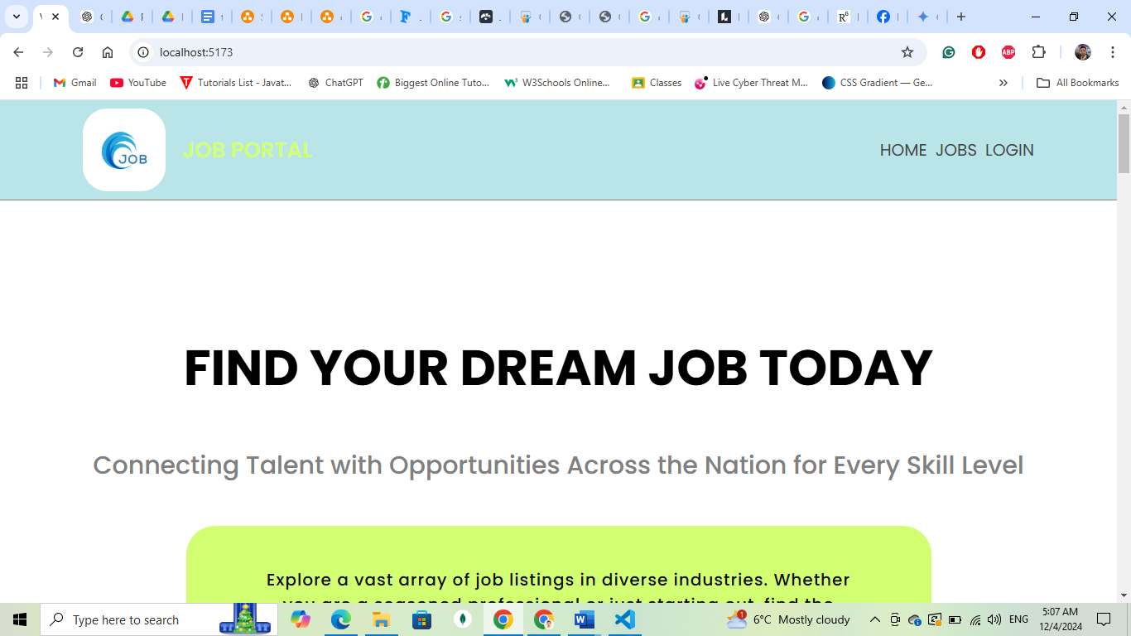

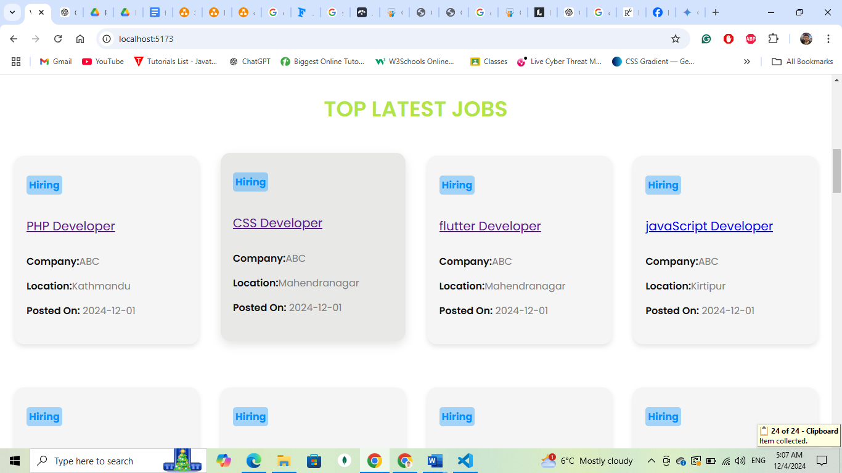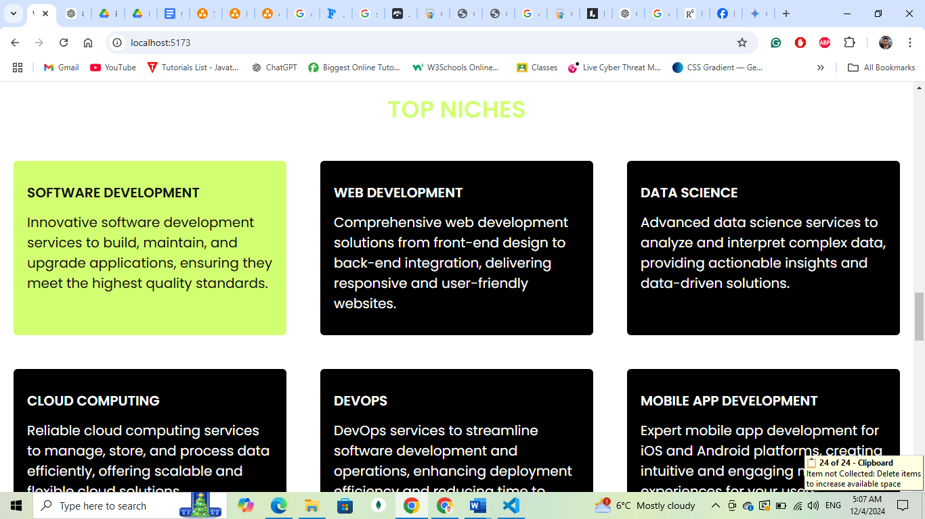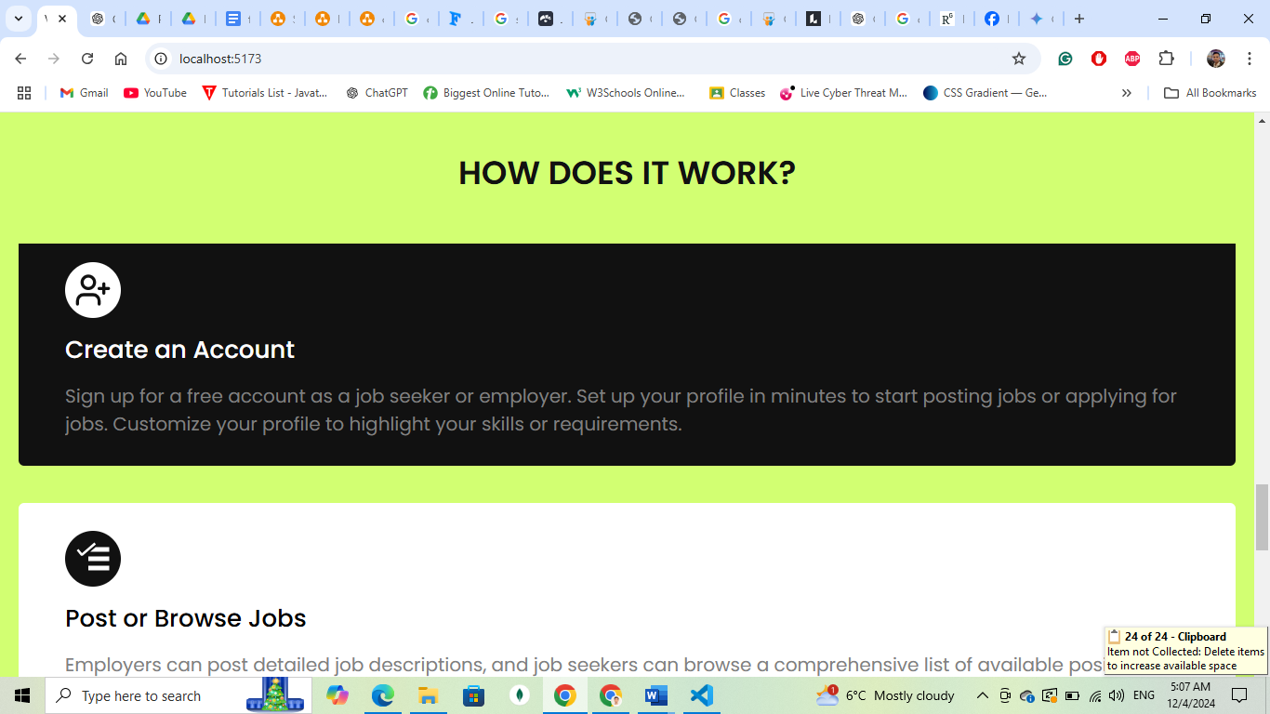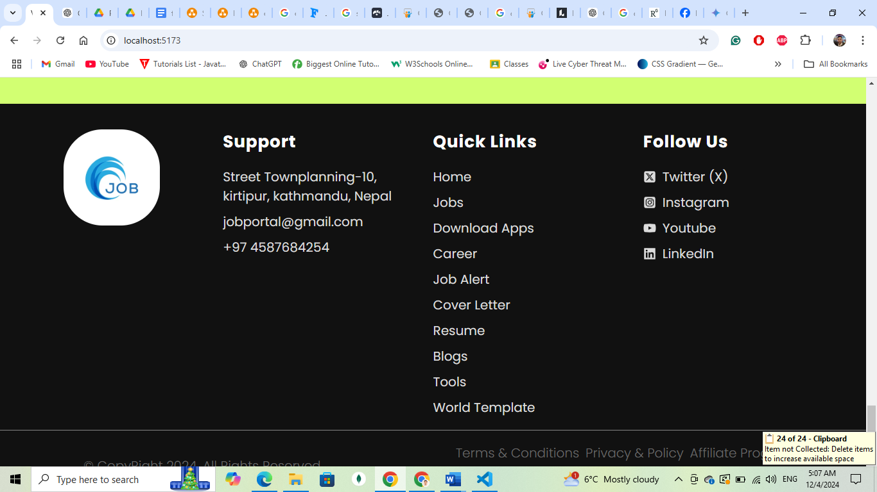

**Appendix** 1**: Home Page for Job Portal**

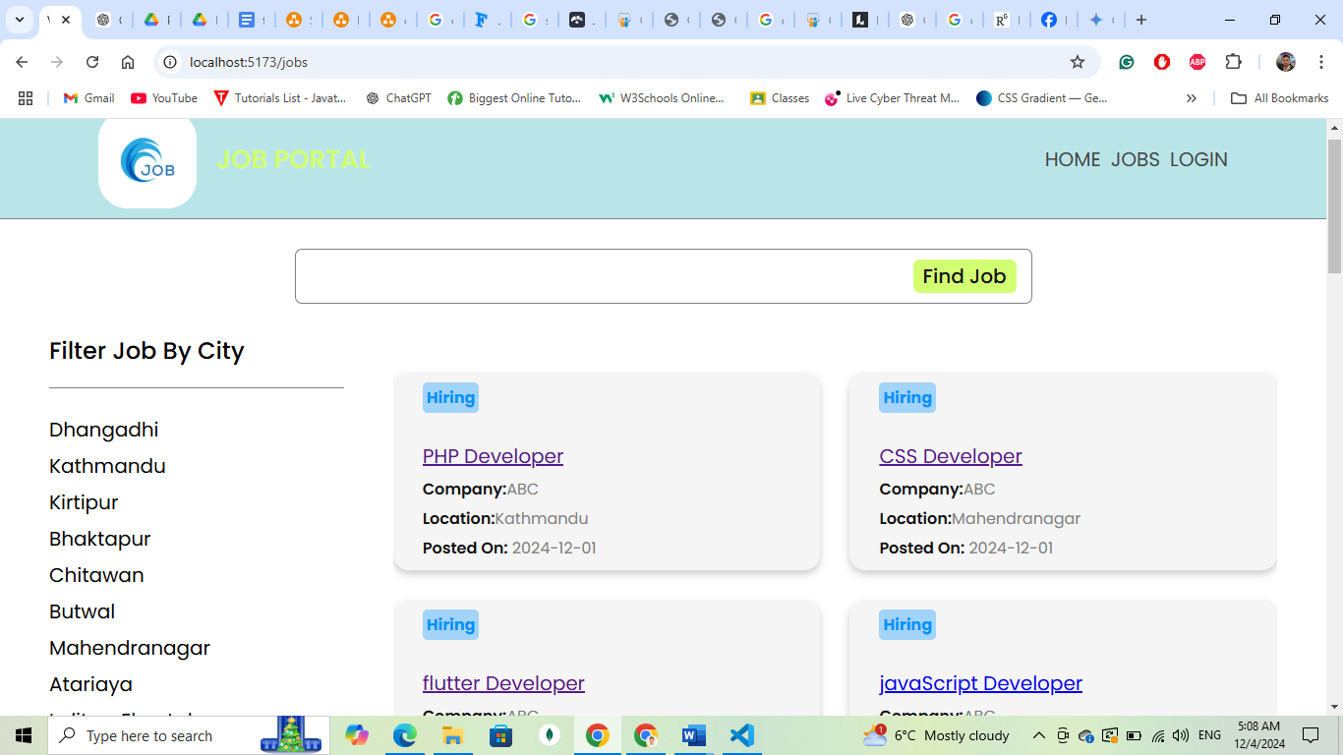

**Appendix** 2**: Job Searching page for Job Portal**

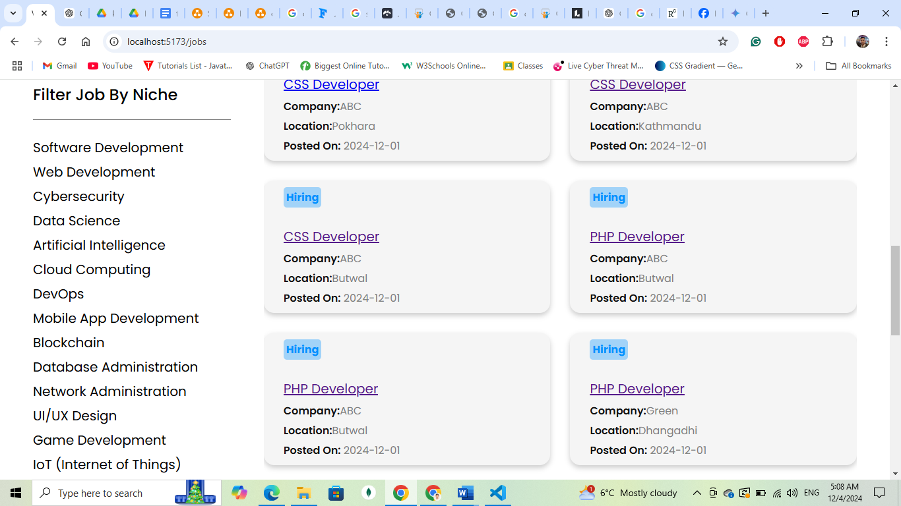

**Appendix** 3**: Job Filter by Niches for Job Portal**

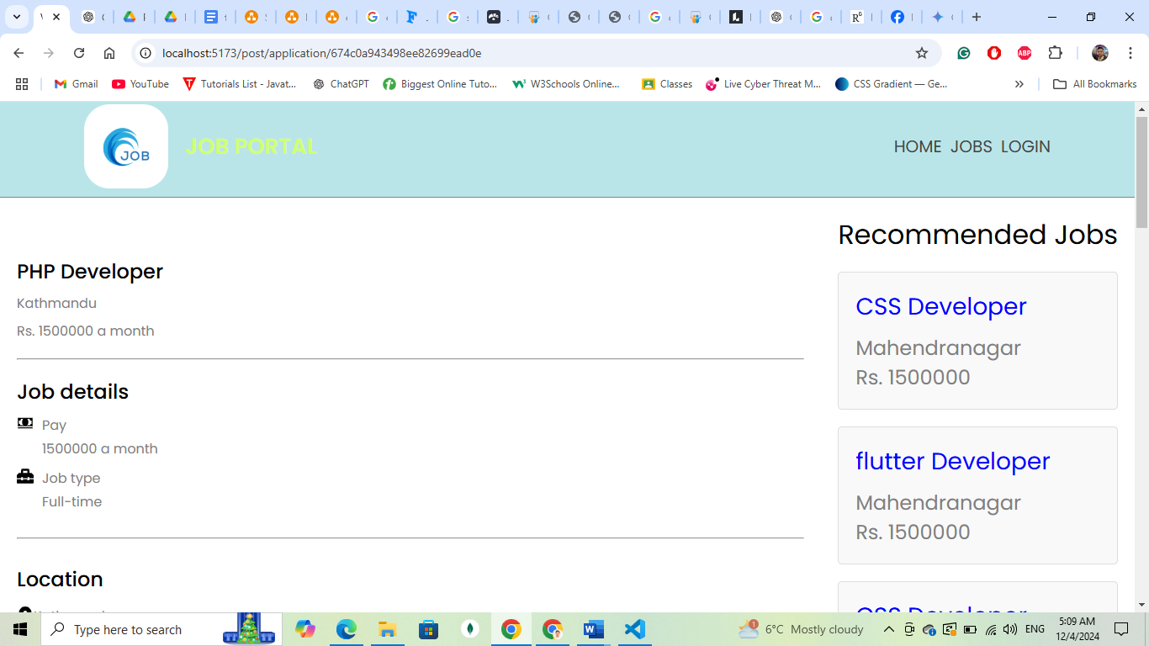

**Appendix** 4**: Single Job Description & Recommendationfor Job Portal**

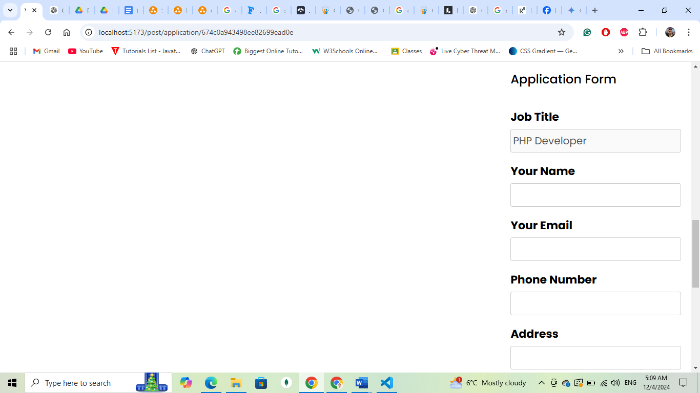

**Appendix** 5**: Application Form for Job Portal**

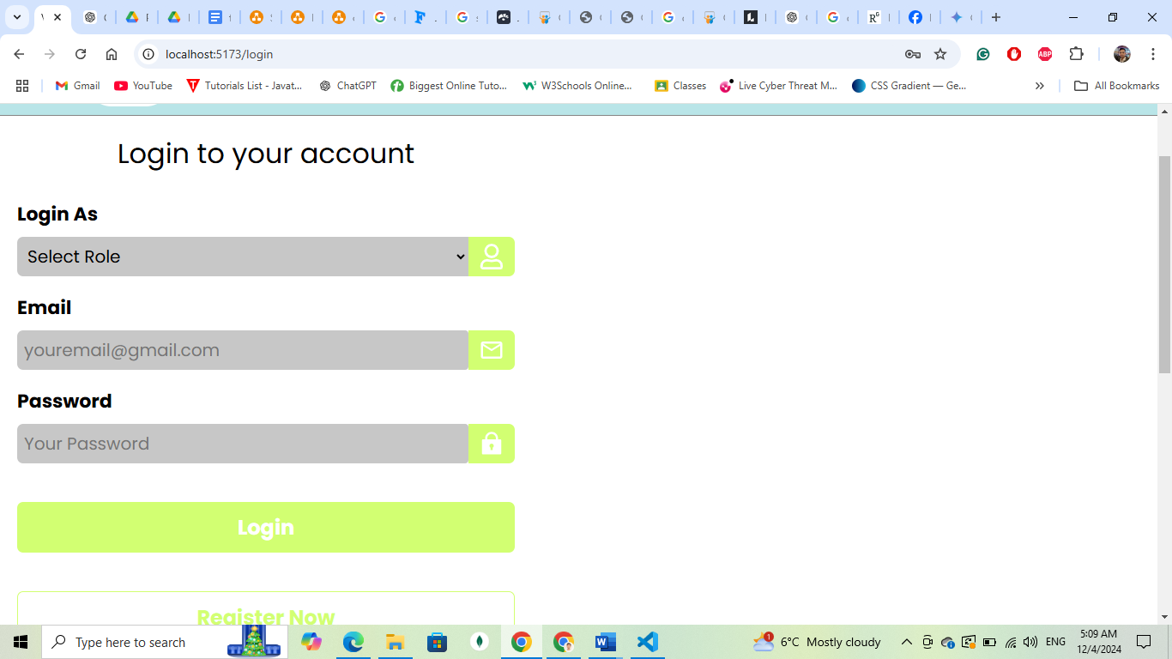

**Appendix** 6**: login Pagefor Job Portal**

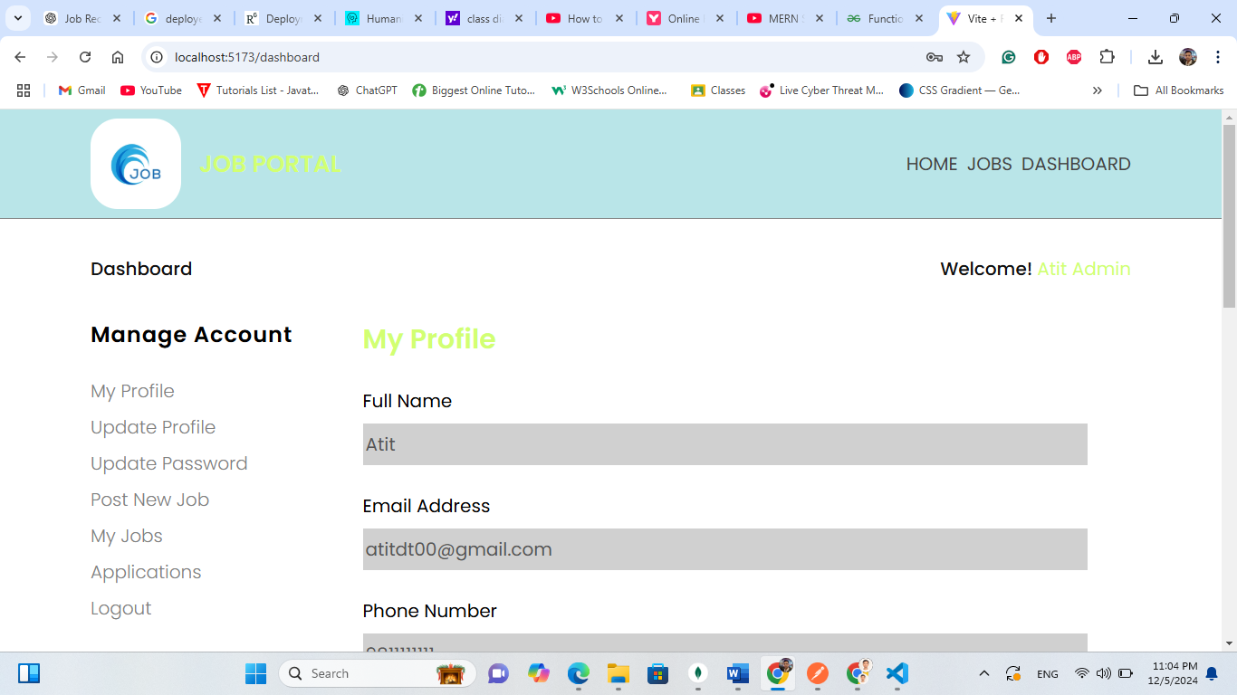

**Appendix** 7**: Admin Profilefor Job Portal**

**Appendix** 8**: Post New Jobs Formfor Job Portal**

Appendix 9: User applicationsfor Job Portal

Appendix 10: Posted Jobfor Job Portal